1. Finding employees earning more than average salary (Scalar Subquery)

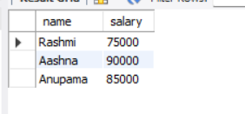

1. Listing names of departments having projects with budget > 100000 (IN)

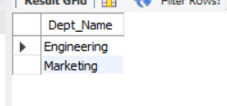

1. Employees not assigned to any project (NOT IN)

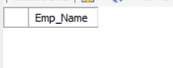

1. Employees with same department as ‘Diya’ (Scalar Subquery)

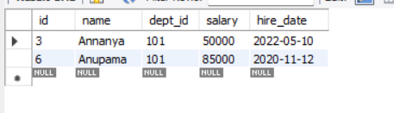

1. Departments with no employees (NOT EXISTS)

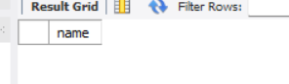

1. Employees who work on more than one project (Correlated Subquery)

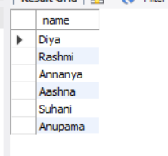

1. Highest paid employee in each department (Correlated Subquery)

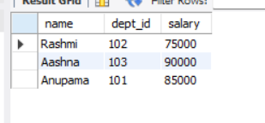

1. Departments with average salary > 65000 (Subquery in FROM)

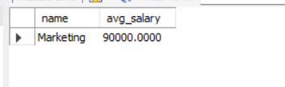

1. Listing projects where all assigned employees are from Engineering (NOT EXISTS + Correlation)

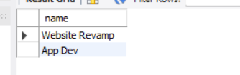

1. Departments with more than 2 employees (IN + GROUP BY)

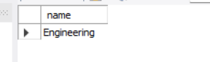

1. Employees working on same projects as 'Alice' (Nested IN)

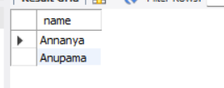

1. Showing all employees and number of projects (Subquery in SELECT)

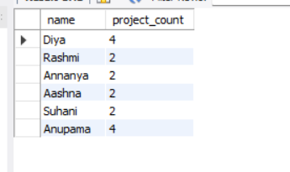

1. Projects not assigned to any employee (NOT EXISTS)

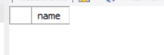

1. Finding employees whose salary > department’s average (Correlated Subquery)

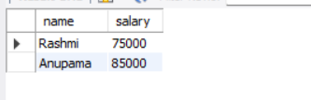

1. Finding employees who earn more than the highest-paid employee in the HR department

